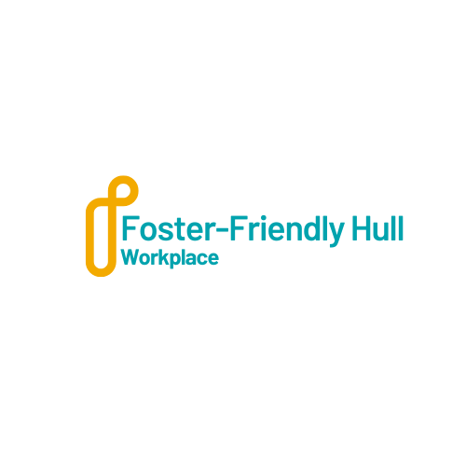

Hull Fostering's "Foster-Friendly Hull" Policy
Hull Fostering is committed to creating a supportive community for foster carers by encouraging local businesses, organisations, and schools to become foster-friendly.
Our "Foster-Friendly Hull" scheme aims to provide foster carers with additional support and recognition, while also promoting the importance of fostering within our community.
This policy outlines the agreement and benefits for entities that join our initiative.

Policy and Agreement
Local businesses, organisations, and schools in Hull are invited to join the "Foster-Friendly Hull" scheme by committing to the following:
- Support for Foster Carers:
Entities that join the "Foster-Friendly Hull" scheme can provide various forms of support to foster carers, including but not limited to:
- Special Offers: Discounts on products or services, exclusive promotions, or loyalty programs tailored for foster carers.
- Flexible Work Arrangements: Adjusted work hours, remote work options, or additional leave to accommodate the needs of foster carers.
- Awareness and Advocacy: Sharing information about fostering opportunities and the benefits of becoming a foster carer within their networks and customer base.

- Community Engagement:
Entities that join the "Foster-Friendly Hull" scheme can provide various forms of community engagement to Hull Fostering, including but not limited to:
- Participate in local events and campaigns organised by Hull Fostering to raise awareness about fostering.
- Display "Foster-Friendly Hull" promotional materials to show their support.

Benefits and Recognition
By joining the "Foster-Friendly Hull" scheme, businesses, organisations, and schools will receive the following benefits:
- Recognition: Public acknowledgment on Hull Fostering's website, social media channels, and promotional materials as a "Foster-Friendly Hull" supporter.
- Community Impact: Contributing to the well-being of foster carers and children in Hull, creating a positive impact within the community.
- Networking Opportunities: Invitations to exclusive events and networking opportunities with other "Foster-Friendly Hull" supporters and stakeholders.
- Enhanced Reputation: Being recognised as a socially responsible entity that supports foster carers and the fostering community.
Optional National Accreditation:
- Entities can choose to sign up for the Fostering Network’s national accreditation, which includes providing five additional days of annual leave for foster carers.

Hull Fostering's "Foster-Friendly Hull" scheme is designed to create a supportive environment for foster carers by engaging local businesses, organisations, and schools.
By joining this initiative, entities can make a meaningful difference in the lives of foster carers and children, while also benefiting from increased recognition and community engagement.
We invite all eligible entities to become part of this important initiative and help us build a foster-friendly Hull.

Agreement and Signature

By signing below, (name of organisation) _______________________________________ agrees to join the "Foster-Friendly Hull" scheme and commit to the policies and support outlined in this agreement. We understand the importance of fostering within our community and are dedicated to providing additional support and recognition to foster carers.

Business Representative:
Name: _______________________________________
Title: ________________________________________
Signature: ____________________________________Date: _______________________
Hull Fostering Representative:
Name: _______________________________________
Title: ________________________________________
Signature: ____________________________________Date: _______________________

